Tatton Wildlife Newsletter – Summer
Due to the unprecedented outbreak of Covid-19, the park remained closed during spring and into summer. The ranger team continue to work throughout the period, making sure that all our deer and livestock are well looked after. They provide a security presence and monitor the wildlife of the parkland along with getting on with numerous maintenance tasks.
Deer
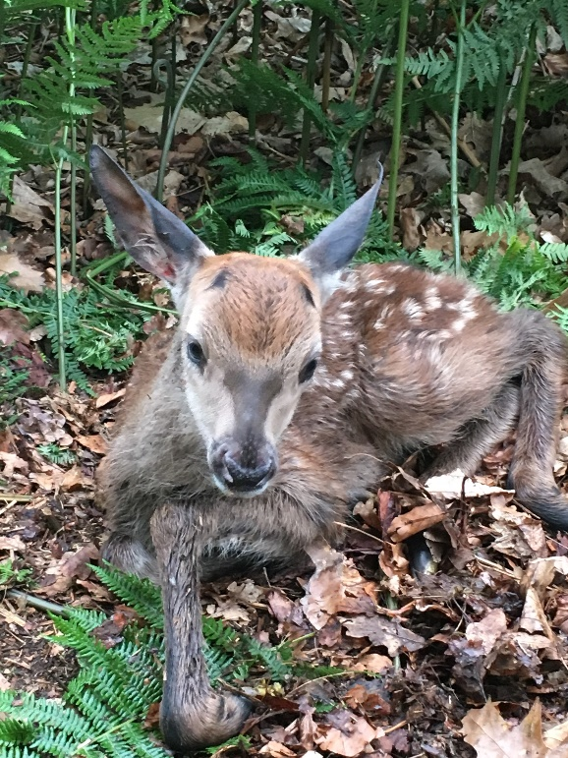
The deer have now fully moulted and look splendid adorned in their summer pelage. The males have split off into their bachelor groups and will laze away the summer days growing their antlers in preparation for the autumn rut. Look closely and you will see that the antler is covered in velvet. They are soft to the touch and any impact to them now will cause deformity as they grow, therefore any disputes at this time of year will not be settled with a clash of antlers but will see them rear up on hind legs and “box” each other.
Meanwhile the females are busy having young. The young of red deer are called calves while the fallow young are fawns. The mother will move away from the herd to a secluded area and literally drop her young in undergrowth or by a fallen branch. It will stay concealed and has no scent, preventing detection from predators. The mother will return to it at night to feed it and this is why it is important that if you find a young deer you leave it alone as the mother knows where it is and it will not have been abandoned. The danger is that if it is interfered with, the mother will reject it and it will be. It is also important that dogs are kept under close control. After a couple of days, the young will be on their feet and be able to follow the mother and can now be seen out in the parkland. The earlier in the summer that they are born, the better, as this gives them more time to grow before the onset of the harsher winter months.
Birds
The closure of the park seems to have been of benefit to Tatton’s birdlife. Having new areas undisturbed has aided them to nest successfully and some unusual species have been seen. A redstart was seen near to the Mill Pool area, this is a rare visitor to Tatton. They are a migratory bird and are normally seen in upland, wooded valleys. This individual was a male in full summer plumage and was probably passing through on the way to its breeding grounds. The last time one was recorded here was over twenty-five years ago!
The first migratory bird to arrive back was a chiffchaff that was seen in Dog Wood on the 13th March followed by a Sand Martin over Tatton Mere on the 21st. The first Swallow arrived on the 5th April. Other unusual summer visitors were three common sandpipers that stayed for a few days in April, they have been seen on the banks of the mere at this time of year before, but they never usually linger. We have had several sightings of kingfishers along with oystercatchers, hobbies, and grey wagtails. Mandarin duck appear to be doing very well and are breeding, as are Egyptian geese again. Wheatears were also noted passing through in spring. Fourteen pairs of herons nested at our heronry this year which is about average for what we usually record here at Tatton. Our heron count is submitted to a BTO national survey that has been running for many years. The survey reveals that during 2019 there were 10,000 nests reported in the U.K. with 432 in Cheshire. One of our rangers is also licenced to monitor our barn owl population and we can report that we do have a breeding pair in the parkland this year. All our bird records are also submitted to a national database called i-records and to the Cheshire and Wirral Ornithological Society for inclusion in the Cheshire Bird Report.
Look out for terns over Tatton Mere during the summer months, we may even get a black tern dropping in. Late summer is a great time to see hobbies too, again, they favour Tatton Mere as a hunting ground.
Butterflies
We are continuing with the butterfly survey which we started last year and so far, a good number of species have been recorded including brimstone, peacock, and small tortoiseshell. As the summer progresses, we expect to see different species as their differing life cycles dictate when they emerge along with the availability of the food plant they require.
Reptiles
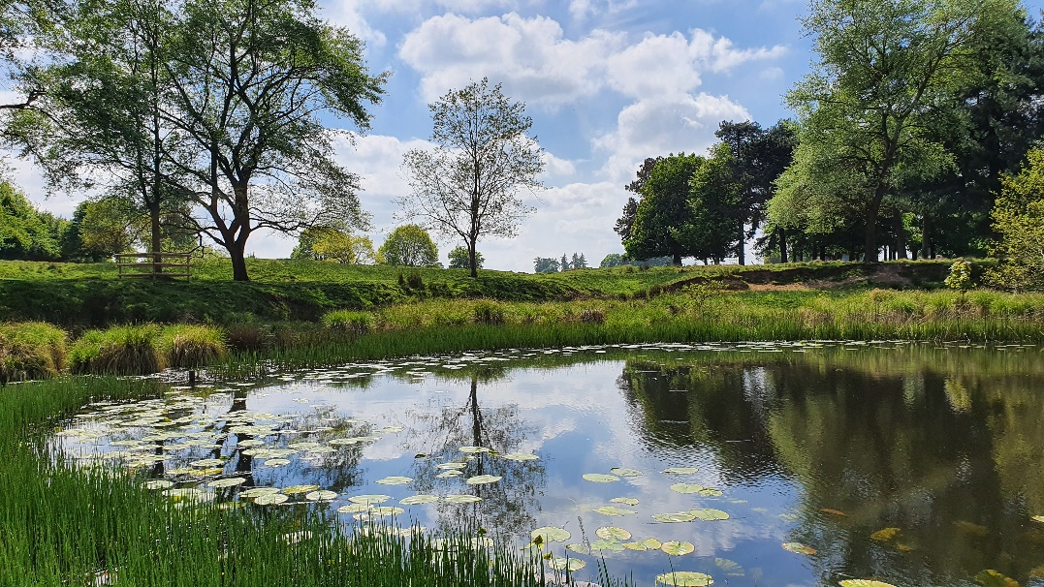
Tatton’s numerous ponds and woodlands provide excellent habitat for several amphibian species, including the common frog, the common toad, the smooth newt, and the great crested newt. The word amphibian means ‘two lives’, an apt name given that these cold-blooded invertebrates spend half of their lives in water and half on land. The damp, decaying dead wood deliberately left in our woodlands provides excellent habitat for amphibians to both hibernate in the winter and to hunt for invertebrate prey in the warmer months.
Compiled by Tatton’s Ranger Team

